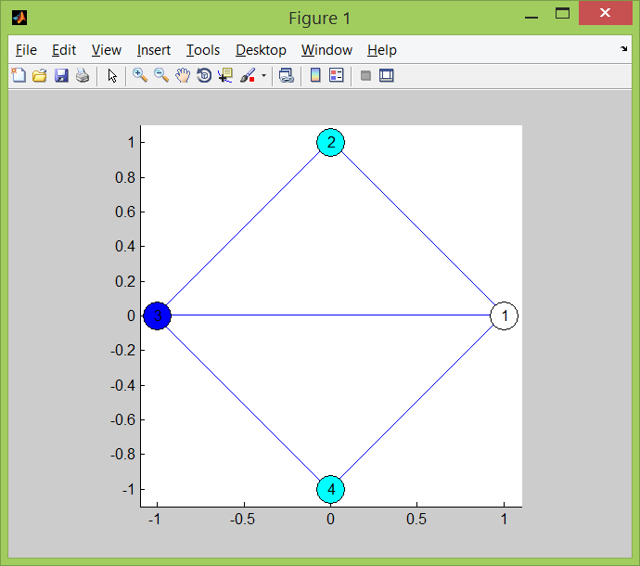

|  |  |
| --- | --- |
| Uz_1.txt | Rezultatas |
| 3  4  0 1 1 1  1 0 1 0  1 1 0 1  1 0 1 0 | Spalvu skaicius: 3  Virsune Spalva:  1 1  2 2  3 3  4 2 |

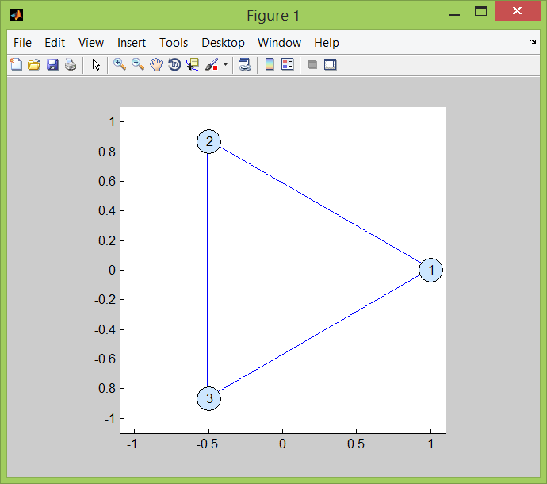

|  |  |
| --- | --- |
| Uz_2.txt | Rezultatas |
| 2  3  0 1 1  1 0 1  1 1 0 | Sprendinys neegzistuoja |

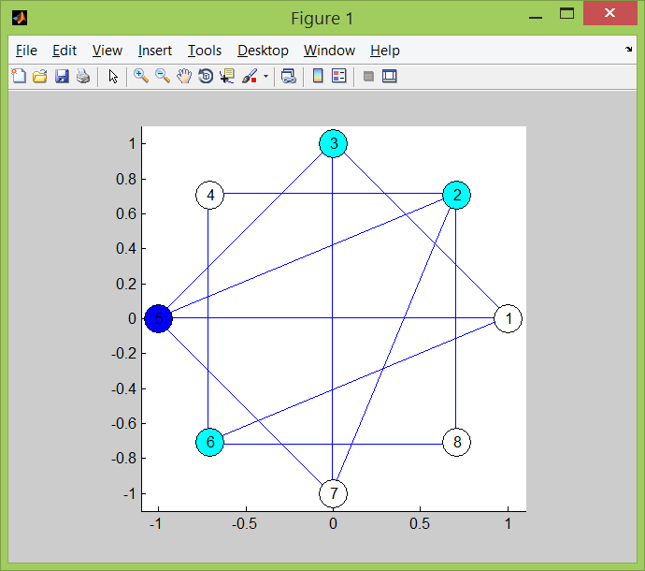

|  |  |
| --- | --- |
| Uz_3.txt | Rezultatas |
| 3  8  0 0 1 0 1 1 0 0  0 0 0 1 1 0 1 1  1 0 0 0 1 0 1 0  0 1 0 0 0 1 0 0  1 1 1 0 0 0 1 0  1 0 0 1 0 0 0 1  0 1 1 0 1 0 0 0  0 1 0 0 0 1 0 0 | Spalvu skaicius: 3  Virsune Spalva:  1 1  2 2  3 2  4 1  5 3  6 2  7 1 |

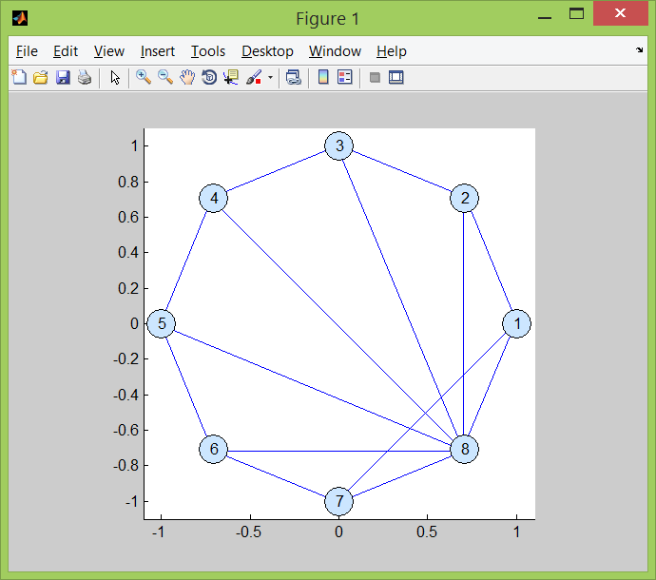

|  |  |
| --- | --- |
| Uz_4.txt | Rezultatas |
| 3  8  0 1 0 0 0 0 1 1  1 0 1 0 0 0 0 1  0 1 0 1 0 0 0 1  0 0 1 0 1 0 0 1  0 0 0 1 0 1 0 1  0 0 0 0 1 0 1 1  1 0 0 0 0 1 0 1  1 1 1 1 1 1 1 0 | Sprendinys neegzistuoja |

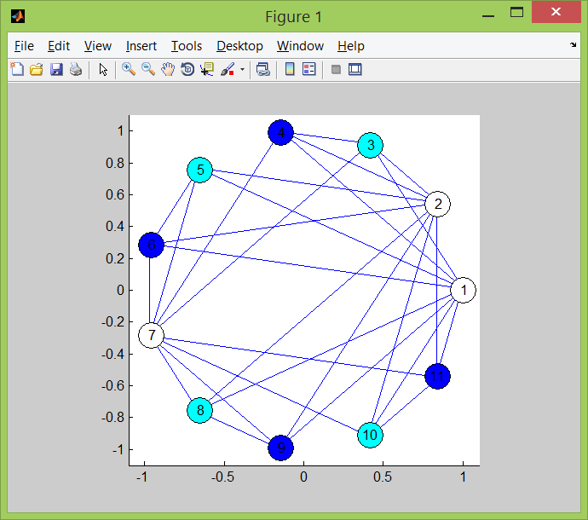

|  |  |  |
| --- | --- | --- |
| Uz_5.txt | Rezultatas (2 variantai) | |
| 3  11  0 0 1 1 1 1 0 1 1 1 1  0 0 1 1 1 1 0 1 1 1 1  1 1 0 1 0 0 1 0 0 0 0  1 1 1 0 0 0 1 0 0 0 0  1 1 0 0 0 1 1 0 0 0 0  1 1 0 0 1 0 1 0 0 0 0  0 0 1 1 1 1 0 1 1 1 1  1 1 0 0 0 0 1 0 1 0 0  1 1 0 0 0 0 1 1 0 0 0  1 1 0 0 0 0 1 0 0 0 1  1 1 0 0 0 0 1 0 0 1 0 | Spalvu skaicius: 3  Virsune Spalva:  1 1  2 1  3 2  4 3  5 2  6 3  7 1  8 2  9 3  10 2  11 3 | Spalvu skaicius: 3  Virsune Spalva:  1 3  2 3  3 1  4 2  5 1  6 2  7 3  8 1  9 2  10 1  11 2 |